boundless

**HELIOS**

Solutions for a space economy

**DOCUMENTED FOR**

NASA SpaceApps Hackathon

HackAthlone

**AUTHORS**

Ahmad Elhan Marzooq Ahmad Martadha

Ngoc Thanh Mai Tran

Jakub Piwosz

Katie Mulvihill

Table of Contents

Executive Summary 1

Vision and Missions 2

Problem Statement 3

Proposed Solutions 3

Business Model 5

Timeline: Phasing 5

PHASE 1 – BM 5

PHASE 2 – BM 7

PHASE 3 – BM 8

Value Proposition 11

Space Debris 12

Infrastructure Resilience 12

Sustainability 12

Target Markets 13

Total Addressable Market (TAM) 13

Serviceable Available Market (SAM) 14

Serviceable Obtainable Market (SOM) 15

Revenue Models 17

Phased Revenue Models 17

Cost Structure 19

Pre-PHASE 1 and PHASE 1 Kick-off 19

PHASE 2 Kick-off and Operations 20

PHASE 3 Hypotheticals 21

Regulations and Legal 22

UNOOSA Outer Space Treaty 22

UNOOSA Outer Space Treaty – Article 7 22

Space Debris Mitigation Guideline 23

Guidelines for the Long-term Sustainability of Outer Space Activities of the Committee on the Peaceful Uses of Outer Space 24

Competition 26

A Realistic Perspective 26

Collaboration 27

KAWAN-67 Drones 28

Space Debris Detection with YOLO V8 MobileNet Machine Learning Model 28

HELIOS 31

Inspiration 31

Models 31

Conclusion 32

References 33

# Executive Summary

The Boundless proposal outlines the industrialization of low-Earth orbit (LEO) infrastructure through its scalable space station, **HELIOS** with a long-term vision to enable expanded human activity across the solar system. HELIOS’s phased business model begins with **Phase 1**, focusing on premium-niche microgravity manufacturing and **Microgravity-as-a-Service (MaaS)**, targeting a revenue potential of $90-$400 million annually by Year 5. This transitions to **Phase 2**, which emphasizes high-volume B2B sales of advanced materials and culminates in **Phase 3**, where the core business shifts to **Logistics-as-a-Service (LaaS)** and **Infrastructure-as-a-Service (IaaS)**, positioning the station as a Lunar Gateway utility and targeting up to $3 billion annually by Year 15. The project's central value proposition is the creation of a **circular economy** by harvesting and recycling space debris, which can be valued in the billions or trillions of dollars into raw materials, thereby reducing the risk of catastrophic collisions and cutting costs associated with launching materials from Earth. Boundless acknowledges the intense competition from existing commercial station developers like Axiom Space and Blue Origin, as well as specialized manufacturers, stressing the necessity of **collaboration** over seeking a monopoly in LEO. The proposal also highlights the technical development of **KAWAN-67 Drones** for space debris detection using a YOLO V8 MobileNet machine learning model.

# Vision and Missions

**Vision**

Boundless seeks to pioneer the industrialization of low-Earth orbit infrastructure, creating a foundation for expanded human activity across the solar system and supporting future interstellar endeavours. Our mission is to transform orbital space into a platform for innovation, enabling unprecedented opportunities for scientific discovery and commercial development.

**Missions**

Boundless aims to introduce large-scale privatization and technological innovations in Earth’s low orbit. However, Boundless aims to do this within realistic margins**.**

|  |  |  |
| --- | --- | --- |
| **Economically** | **Sustainably** | **Scientifically** |
| **Establishing a thriving orbital economy** | **Privatizing sustainable planetary space** | **Pioneering a new scientific frontier** |

Figure 1. Mission statements

HELIOS’s design aims to mitigate the contribution of space debris and a new introduction of resilient space infrastructure.

# Problem Statement

Earth’s low orbit has been eyed as a prospected frontier for a new commercialization and privatization opportunity. Many corporations have already begun to commercialize their operations in this space, however, there has not been any plans to industrialize LEO.

“The CLDC acquisition is on hold. NASA has determined that, rather than moving forward at this time with a firm fixed price contract for CLD certification and services, NASA will continue to support U.S. industry’s design and demonstration of CLDs with funded SAAs for the next phase.  After the SAA phase is enabled, NASA anticipates establishing a follow-on certification and services phase to meet government requirements under a FAR based acquisition.   Details regarding the future acquisition will be released in the future. NASA remains committed to enabling sustainable development of commercially owned and operated LEO destinations under the National Aeronautics and Space Act (Space Act), 51 U.S.C. §§ 20101-20164.”

# Proposed Solutions

HELIOS is a scalable research and manufacturing space station. Starting small, it focuses on quaternary business operations. Partitioned into three stages, HELIOS phases help in managing economies-of-scale and changing business objectives. These phases will be further expanded upon in the following page of this document.

Figure 2. Inspiration of the phases of the HELIOS scaling infrastructure

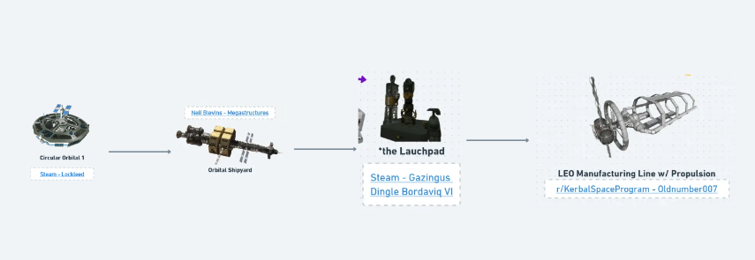Model images. By Lockleed; Blevins; Gazingus Dingle Bordaviq VI; Oldnumber007

# Business Model

While the solution to a thriving LEO economy does not change, the methods that are used to enact that solution will inevitably require alterations.

## Timeline: Phasing

### PHASE 1 – BM

**Premium-niche product sales**

The primary revenue stream would come from selling the physically manufactured, high-value, small-scale products that benefit from the microgravity environment.

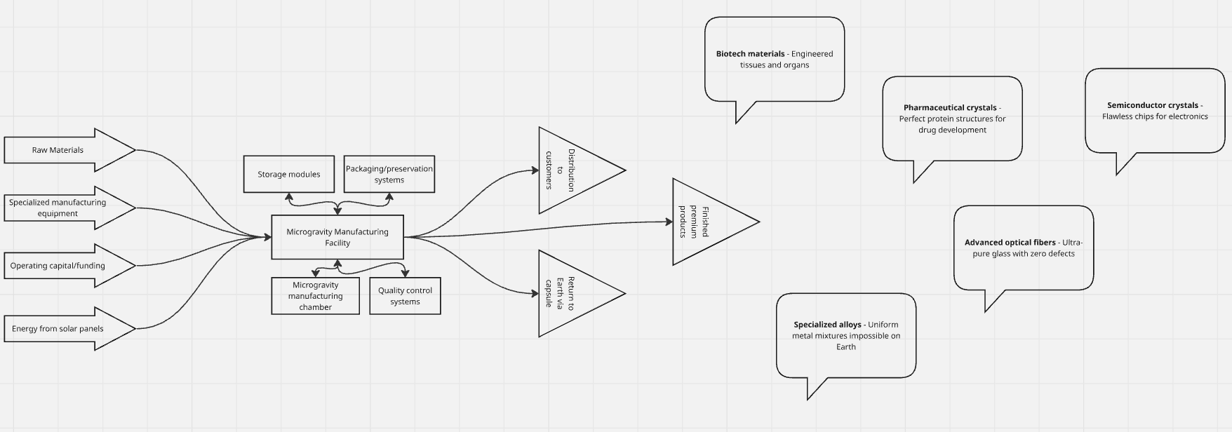Figure 3. Visualized premium-niche product sales

**MaaS (Microgravity-as-a-Service)**

The HELIOS station is small and focused on advancing knowledge, then leasing out the manufacturing/research capacity is an excellent way to secure guaranteed revenue and reduce risk.

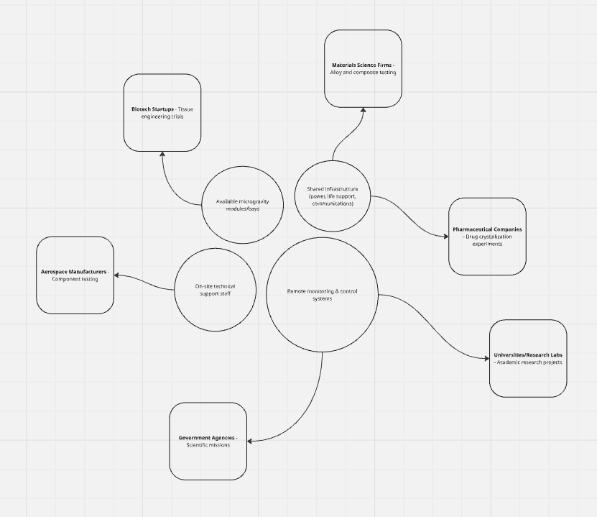Figure 4. Visualized MaaS

### PHASE 2 – BM

**High-volume B2B sales**

The focus shifts from selling tiny, ultra-premium batches to a few research labs, to selling larger volumes to major industrial players.

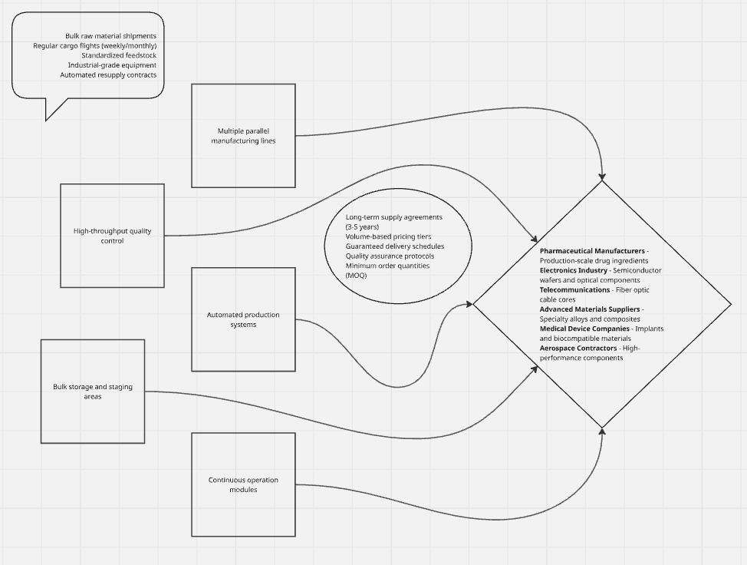Figure 5. Visualized high-volume B2B sales

**MaaS2 (Microgravity-as-a-Service)**

The MaaS model is still relevant but would be restructured to prioritize partners who can commit to volume production.

### PHASE 3 – BM

**LaaS and IaaS**

Infrastructure-as-a-Service (IaaS) and Logistics-as-a-Service (LaaS**)** focus, with manufacturing becoming an anchor tenant and a key supporting function. The core business is no longer selling materials; it is selling access, movement, and support.

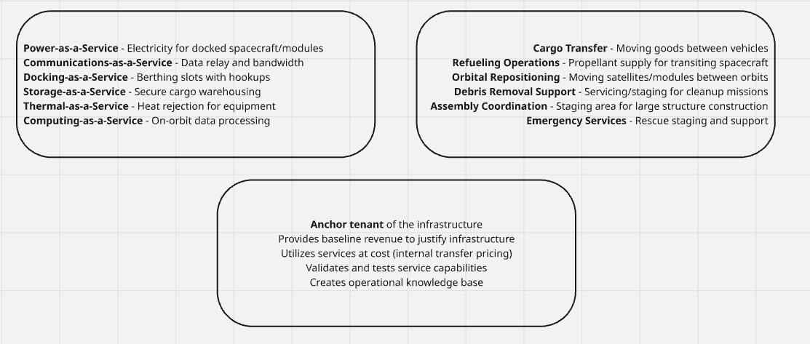Figure 7. Visualized logistics and infrastructure plan

**Input supplier**

HELIOS’s existing manufacturing modules now have a dual purpose: they still sell high-value materials back to Earth, but their new, more strategically vital role is to supply the adjacent logistics and space economy.

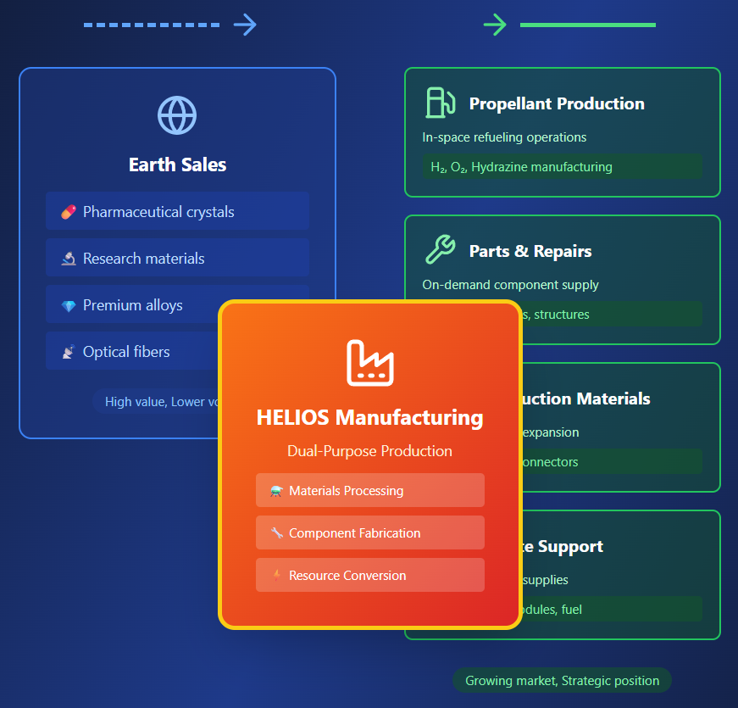Figure 8. Visualized ideal space economy (AI Generated)

**Lunar gateway**

In this final phase, the business model moves to maximize the value of its geographic location (LEO/Cislunar Gateway) and its infrastructure capability (the ports), making it less dependent on the volatility of any single manufactured product's market on Earth. It is a logistics utility that enables the entire future of cislunar and deep-space economy.

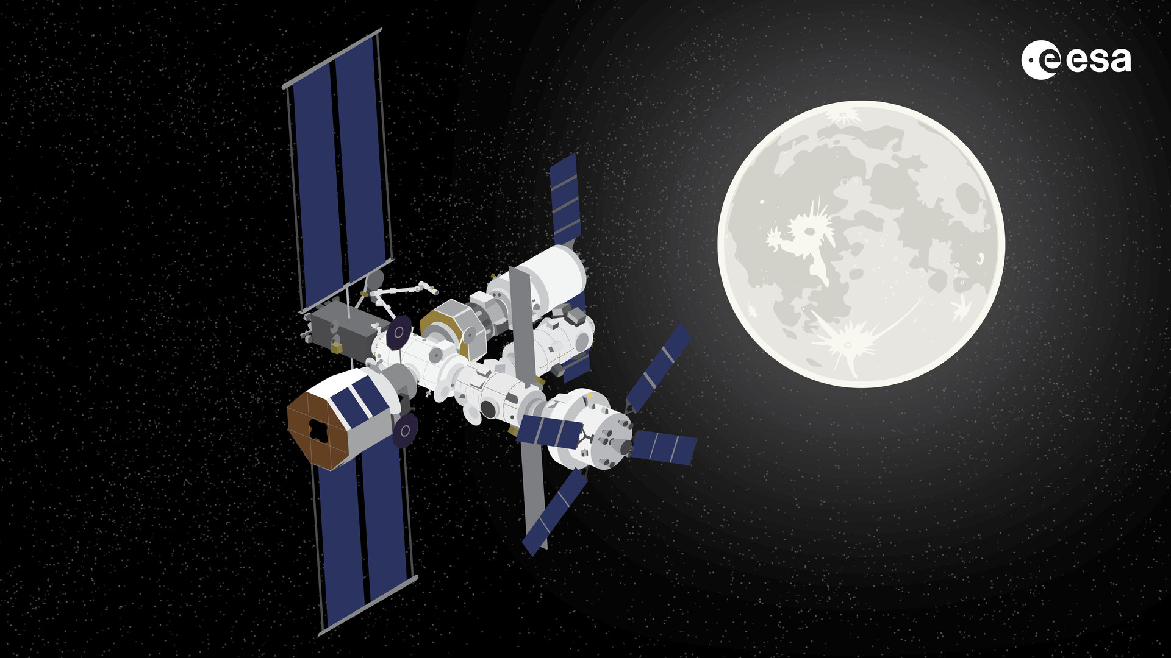Figure 9. ESA’s rendition of the lunar gateway (ESA)

## Value Proposition

**The circular economy**

A space factory designed to build new rockets and OLVs (orbital launch vehicles) would certainly allow for larger ambitions in the deep reaches of space. Creating a sustainable and recyclable production process will help in maintaining a circular space economy.

While LEO does not have large deposits of raw minerals, it does harbour the orbits of tens of thousands (30 - 40,000 large recyclable wreckage) recyclable wreckage that can be harvested. These materials can then be used to manufacture new rockets or spacecraft at the space factory and then be launched from the space factory for optimal energy trades in extra-terrestrial missions.

The caveat with this vision is that, while trying to retrieve space wreckage, it may well be possible that more wreckage be created as a result.

*Why is this?*

Space debris in orbit moves at an extremely fast velocity making small debris pieces more akin to small kinetic mass drivers (a bullet, for those uninitiated). That is why it is imperative that future harvester drones be equipped with the right technology to harvest these debris.

**Production economy**

Manufacturing does not always have to be big and ambitious. In fact, manufacturing in zero-g can benefit the other extremes of the industry such as nano-technology. While it is completely possible to manufacture technology such as chips, crystals, and optical products in Earth’s gravitational field, its micro-vibrations can severely impact its end quality. Producing these micro-products in a zero-g environment allows for a further increase in quality and performance of these technologies.

Instead of solely focusing on the harvesting and processing of materials, there is a need to scale to everchanging business supply and demand. Current rising trends of 3D printing machinery could be further advanced and innovated in zero-g environments allowing for more creative and complex printable blueprints at both large and small scales too.

### Space Debris

Space debris, valued potentially in the billions or even trillions of dollars as a resource, can be harvested and recycled into raw materials (e.g., aluminium, propellants). This creates a new market, reduces the dependence on costly materials launched from Earth, and potentially funds active debris removal (ADR) missions. Recycled materials on the Moon could cost a fraction of materials transported from Earth.

Actively managing and removing debris reduces the risk of catastrophic collisions (Kessler Syndrome), which can destroy operational satellites. The value of avoided risk to operators can be millions of dollars annually, providing a service fee-based business model for Active Debris Removal (ADR) companies.

### Infrastructure Resilience

Resilient design (e.g., distributed LEO constellations, on-orbit servicing capabilities) extends the operational life of assets and reduces the need for expensive replacement launches. This directly translates to lower capital expenditures (CapEx) over time and more stable, long-term revenue streams for investors and operators.

### Sustainability

Sustainable practices, such as minimal-energy recycling (e.g., recycling aluminium requires only 5% of the energy of primary production), lead to long-term operational cost savings. Proactive compliance with evolving international space debris mitigation and regulatory frameworks avoids future penalties and operational delays.

## Target Markets

### Total Addressable Market (TAM)

The TAM represents the entire LEO commercial opportunity across all segments relevant to the business model.

**LEO satellite & infrastructure market:** the LEO satellite market is estimated at $197.1 billion in 2025 and expected to reach $304.7 billion by 2030 (Mordor Intelligence, n.d.), though more conservative estimates place it between $11.81 billion in 2025 growing to $20.69 billion by 2030 (Mordor Intelligence, n.d.). The variance reflects different methodologies and scope definitions.

**Space manufacturing market:** the market for materials manufactured in space could reach $10 billion by 2030 (Petrova, 2023), with pharmaceuticals in space potentially generating $2.8 billion to $4.2 billion in revenues (Hirschberg, Kulish, Rozenkopf, & Sodoge, 2022).

**Estimated TAM (conservative):** $25-35 billion by 2030, encompassing:

* LEO infrastructure services
* microgravity manufacturing
* pharmaceutical production
* advanced materials production
* orbital services (docking, debris removal, assembly)
* gateway services for lunar/asteroid missions

### Serviceable Available Market (SAM)

The SAM focuses on segments that can realistically address with Boundless’s specific business model.

**PHASE 1 SAM (pharmaceuticals & nanotechnology)**

* **Primary market:** pharmaceutical production in microgravity ($2.8-4.2 billion potential) (Hirschberg, Kulish, Rozenkopf, & Sodoge, 2022).
* **Current activity:** companies like Varda Space are already producing pharmaceuticals in orbit, demonstrating market validation.
* **Estimated PHASE 1 SAM:** $3-5 billion (2026-2030)

**PHASE 2 SAM (advanced materials & scaled production)**

* Optical fibre production
* Zero-g metallurgy and alloys
* 3D materials synthesis
* Fluid dynamics applications
* **Estimated PHASE 2 SAM:** $5-8 billion (2030-2035)

**PHASE 3 SAM (infrastructure & gateway services)**

* NASA's commercial LEO development program has allocated $2.1 billion over five years for commercial space station development (Cowing, 2025).
* Spacecraft assembly services
* Debris collection/recycling
* Docking infrastructure
* Lunar gateway services
* **Estimated PHASE 3 SAM:** $8-15 billion (2035-2040)

**Combined SAM:** $16-28 billion across all three phases

### Serviceable Obtainable Market (SOM)

The SOM represents a realistic market capture based on competitive positioning, first-mover advantages, and execution capability.

**PHASE 1 SOM (Years 1-5)**

**Target:** 3-8% of pharmaceutical/nanotech manufacturing SAM

* **Rationale:** first commercial station faces competition from ISS utilization; Varda's capsule approach; and other commercial station developers.
* **Revenue potential:** $90-400 million p.a. by Year 5
* **Key success factors:**
  + Proprietary processes for specific drug crystallization
  + Long-term pharmaceutical partnerships
  + Cost advantages over capsule-based competitors

**PHASE 2 SOM (Years 6-10)**

**Target:** 5-12% of advanced materials SAM

* **Rationale:** infrastructure advantage from PHASE 1; economies of scale; established customer base.
* **Revenue potential:** $250 million - $1 billion p.a by Year 10
* **Key success factors:**
  + Proven volume manufacturing capability
  + Proprietary metallurgy and materials IP
  + Multiple revenue streams (pharma + materials)

**PHASE 3 SOM (Years 11-15)**

**Target:** 10-20% of LEO infrastructure services SAM

* **Rationale:** significant first-mover advantage, established infrastructure, monopolistic tendencies in dock/assembly services
* **Revenue potential:** $800 million - $3 billion annually by Year 15
* **Key success factors:**
  + Dominant docking infrastructure position
  + NASA and commercial contracts for gateway services
  + Vertical integration advantages (manufacturing + services)
  + Space debris recycling creates barrier to entry

**Conservative SOM projection: $100M → $500M → $1.5B (years 5, 10, 15)**

**Optimistic SOM Projection: $400M → $1B → $3B (years 5, 10, 15)**

**Critical market considerations**

1. **Competition timeline:** a phased approach faces competition from Axiom Space, Blue Origin's Orbital Reef, Northrop Grumman, and other NASA CLD program participants who are already in development phases.
2. **Regulatory environment:** US executive orders announced in February 2025 aimed at reducing regulatory friction could create additional momentum for commercial ventures (Insight, 2025), potentially accelerating market development.
3. **Capital requirements:** each phase requires substantial capital ($500M-2B+ per phase), making VC and government partnerships essential.
4. **ISS transition:** The ISS retirement creates urgency but also uncertainty in the 2030-2031 timeframe, affecting phase 2 market entry timing.
5. **Market creation:** phases 2-3 involve substantial market creation (not just capture), requiring customer education and demand generation investments.

## Revenue Models

## Phased Revenue Models

**Microgravity research/production (PHASE 1, 2, 3)**

Leasing dedicated manufacturing space (e.g., fibre optics, semiconductors, biotech) to clients who send raw materials and proprietary equipment.

**Lease/subscription fee (access to lab/factory space) + royalty on final product value** (equity or revenue share for breakthrough products).

**Orbital refuelling/propellant depot (PHASE 2, 3)**

Sales of storable propellants (e.g., hydrazine, xenon for electric propulsion) to client satellites and transfer vehicles.

**Value-based pricing: $/kg of fuel delivered in orbit** (significantly higher than launch cost, justified by mission extension/completion value). *Example: OrbitFab charges ~$20M for 100kg of hydrazine in GEO* (OrbitFab, 2022)*.*

**Data & communications relay (PHASE 2, 3)**

Leasing communication time and bandwidth through the LEO hub to customers operating in LEO, cis-Lunar space, and at the lunar gateway.

**Subscription or usage-based Fee** (gigabit/sec/month or per-minute, similar to terrestrial telecom).

**"SAFEHAVEN" storage (PHASE 2, 3)** parking space rental for non-operational or *in-storage* satellites waiting for transfer, servicing, or disposal. **A per-unit/per-month fee.**

**Debris-recycled materials (ISRU) (PHASE 3)**

Selling certified metals and composites created from recycled space debris to LEO customers for repair, shield manufacturing, or new spacecraft assembly.

**Commodity spot pricing** (Based on purity and market demand) **+ sustainable surcharge** (Premium for "space-sourced" material).

**In-situ spacecraft assembly (PHASE 3)**

Building large, custom spacecraft in orbit from parts delivered on multiple launches, eliminating the need for single-launch size constraints.

**Time & materials (T&M) contract + project-based fee** (based on complexity and final mass).

**LEO docking & staging (PHASE 3)**

Guaranteed, timed docking access to the hub for a fixed duration. Essential for launch providers, satellite operators, and future orbital hotels.

**Per-dock/per-day Fee** (high-volume, fixed-rate) **+ priority surcharge** (for immediate or high-risk manoeuvres).

## Cost Structure

### Pre-PHASE 1 and PHASE 1 Kick-off

**Preliminary Costs**



Figure x. Cost Table (i)

**Manufacturing Costs**



Figure x. Cost Table (ii)

**Launch Costs**



Figure x. Cost Table (iii)

**Assembly Costs**



Figure x. Cost Table (iv)

### PHASE 2 Kick-off and Operations

**Manufacture, launch, and assembly**



Figure x. Cost Table (v)

**Recurring Costs**

*Crew and Logistics*



Figure x. Cost Table (vi)

*Maintenance and Utilities*



Figure x. Cost Table (vii)

### PHASE 3 Hypotheticals

**Lunar gateway, launch, and assembly costs**



Figure x. Cost Table (viii)

**Deep space and cislunar infrastructure costs**



Figure x. Cost Table (ix)

## Regulations and Legal

### UNOOSA Outer Space Treaty

**Resolution 2222 – (areas of concern)**

***The exploration and use of outer space shall be carried out for the benefit and in the interests of all countries and shall be province of all mankind;***

The concern of commercialization is the presence of monopolization. This resolution helps ensure that not one industrial conglomerate can gain absolute commercial and legislative control of the entirety of the LEO space.

***The Moon and other celestial bodies shall be used exclusively for peaceful purposes;***

This resolution ensures that any cislunar activity in the near future will remain purely for either commercial or scientific purposes.

***States shall be responsible for national space activities whether carried out by governmental or non-governmental entities;***

This affects whichever nation-state that hosts Boundless’s activities. Any liabilities will also be liable towards both Boundless and the nation-state host.

***States shall avoid harmful contamination of space and celestial bodies***

Boundless’s mission of sustainable manufacturing plays an even greater importance in upholding this resolution’s mandate.

### UNOOSA Outer Space Treaty – Article 7

**Resolution 2777 – (area of concern)**

***Each State Party to the Treaty that launches or procures the launching of an object into outer space, including the moon and other celestial bodies, and each State Party from whose territory or facility an object is launched, is internationally liable for damage to another State Party to the Treaty or to its natural or juridical persons by such object or its component parts on the Earth, in air or in outer space, including the moon and other celestial bodies.***

This resolution elaborates on the specificity of Article 7 within the UNOOSA Outer Space Treatise. While not outwardly stated, private organizations who operate within a nation-state will inherently share its liabilities with its host nation-state.

### Space Debris Mitigation Guideline

**Guideline 1 Limit debris released during normal operations**

Limiting debris released during normal operations promotes a more sustainable circular space economy and attractive industrial market for ecological manufacturing. This will also help in alleviating debris pile-up in the LEO space.

**Guideline 2 Minimize the potential for break-ups during operational phases**

Maintaining a robust spacecraft with limited break-ups helps with the recyclability of the space industry and promotes a circular economy in a commercial LEO space.

**Guideline 3 Limit the probability of accidental collision in orbit**

By actively planning around avoidance of launch collisions with already present space debris in LEO, it helps reduce the exponential contribution of more space debris.

**Guideline 4 Avoid intentional destruction and other harmful activities**

Attempt to rationalize a non-orbital break-up for launch operations and on-orbit operations. Doing this ensures that either spacecraft debris returns to Earth, or does not contribute to the ever-growing pile of orbiting space debris.

**Guideline 5 Minimize potential for post-mission break-ups resulting from stored energy**

“By far the largest percentage of the catalogued space debris population originated from the fragmentation of spacecraft and launch vehicle orbital stages. The majority of those break-ups were unintentional; many arising from the abandonment of spacecraft and launch vehicle orbital stages with significant amounts of stored energy. The most effective mitigation measures have been the passivation of spacecraft and launch vehicle orbital stages at the end of their mission. Passivation requires the removal of all forms of stored energy, including residual propellants and compressed fluids and the discharge of electrical storage devices.”

**Guideline 6 Limit the long-term presence of spacecraft and launch vehicle orbital stages in the low-Earth orbit (LEO) region after the end of their mission**

**Guideline 7 Limit the long-term interference of spacecraft and launch vehicle orbital stages with the geosynchronous Earth orbit (GEO) region after the end of their mission**

### Guidelines for the Long-term Sustainability of Outer Space Activities of the Committee on the Peaceful Uses of Outer Space

**Guideline A.1 Adopt, revise and amend, as necessary, national regulatory frameworks for outer space activities**

“With the increase in outer space activities by governmental and non-governmental actors from around the world, and considering that States bear international responsibility for the space activities of non-governmental entities, States should adopt, revise or amend regulatory frameworks to ensure the effective application of relevant, generally accepted international norms, standards and practices for the safe conduct of outer space activities.”

**Guideline A.2 Consider a number of elements when developing, revising or amending, as necessary, national regulatory frameworks for outer space activities**

It is imperative that Boundless applies all of the items the Guideline necessitates.

**Guideline A.3 Supervise national space activities**

“In supervising space activities of non-governmental entities, States should ensure that entities under their jurisdiction and/or control that conduct outer space activities have the appropriate structures and procedures for planning and conducting space activities in a manner that supports the objective of enhancing the long-term sustainability of outer space activities, and that they have the means to comply with relevant national and international regulatory frameworks, requirements, policies and processes in this regard.”

In addition to the first statements, the following statements and its necessities must also be followed to ensure that commercialization operations for Boundless remains standardized.

**Guideline A.4 Ensure the equitable, rational and efficient use of the radio frequency spectrum and the various orbital regions used by satellites**

**Guideline B.3 Promote the collection, sharing and dissemination of space debris monitoring information**

“States and international intergovernmental organizations should encourage the development and use of relevant technologies for the measurement, monitoring and characterization of the orbital and physical properties of space debris. States and international intergovernmental organizations should also promote the sharing and dissemination of derived data products and methodologies in support of research and international scientific cooperation on the evolution of the orbital debris population.”

In order to foster a collaborative LEO commercial bloc, Boundless must adhere to this specific guideline to ensure its own survival and prosperity.

**Guideline B.8 Design and operation of space objects regardless of their physical and operational characteristics**

“States and international intergovernmental organizations are encouraged to promote design approaches that increase the trackability of space objects…”

In addition to alleviate the rising amount of space debris in the LEO space, adhering to this guideline will allow for a much smoother circular economy in LEO for the foreseeable future.

**Guideline B.9 Take measures to address risks associated with the uncontrolled re-entry of space objects**

**Guideline C.1 Promote and facilitate international cooperation in support of the long-term sustainability of outer space activities**

“States and international intergovernmental organizations should promote and facilitate international cooperation…”

**Guideline C.2 Share experience related to the long-term sustainability of outer space activities and develop new procedures, as appropriate, for information exchange**

**Guideline C.3 Promote and support capacity-building**

**Guideline D.1 Promote and support research into and the development of ways to support sustainable exploration and use of outer space**

**Guideline D.2 Investigate and consider new measures to manage the space debris population in the long term**

## Competition

### A Realistic Perspective

Boundless faces distinct competitive challenges in each of its three phases, progressing from specialized microgravity ventures to major global aerospace infrastructure. Analysing the obstacles impeding growth or industrial commercialization will help in forming a better perspective on a hypothetically commercialized LEO.

PHASE 1, the competition in the initial phase, focused on advanced pharmaceuticals and nanotechnology, is divided into two primary categories. First, boundless will compete with the "landlords" of LEO. Companies that are actively developing the next generation of commercial space stations to replace the ISS, such as Axiom Space, Starlab (Voyager Space/Airbus), and Orbital Reef (Blue Origin/Sierra Space). These entities control the very platforms needed for its operations. Second, Boundless faces specialized manufacturing rivals like Varda SpaceIndustries, which has already demonstrated success in autonomous, microgravity-enabled drug manufacturing and Earth return. The ability to secure initial venture capital and prove the unique value proposition of specific products against these established or well-funded players will be critical.

PHASE 2, transitioning to volume manufacturing, competition shifts from R&D to market scalability. companies that have already mastered niche, high-value processes become direct rivals; for instance, Redwire is a proven competitor in ZBLAN optical fibre production, one of Boundless’s key targets. Furthermore, traditional terrestrial manufacturers and aerospace primes like Lockheed Martin and Boeing have the resources to enter high-value materials markets like zero-g metallurgy once the business case is clear. The overarching challenge in this phase is the "Earth Premium"—Boundless must continuously prove that the superior purity and structure of space-manufactured goods justify the immense cost premium over ever-improving, highly efficient manufacturing processes here on Earth.

PHASE 3, the final, most ambitious phase of monopolizing LEO and establishing gateway infrastructure places Boundless in direct competition with major global powers and giants of the space industry. In-situ assembly and debris recycling functions put boundless squarely against the emerging In-Space Servicing, Assembly, and Manufacturing (ISAM) sector, spearheaded by companies like Northrop Grumman/SpaceLogistics and dedicated startups such as Astroscale. Crucially, ambitions to be a Lunar/NEA Gateway puts Boundless into competition with massive, state-backed programs like NASA's Lunar Gateway and the dominant heavy-lift launch provider, SpaceX's Starship program. If Starship delivers cheap, frequent, deep-space transportation, standalone LEO gateway may lose its competitive advantage as the primary orbital refuelling and assembly hub.

## Collaboration

Due to the many other established businesses and corporations establish or to-establish markets in LEO, Boundless would find itself struck in a market with much stronger commercial and political influences. Acting adversely can catastrophically diminish any possible ambitions for both Boundless and the LEO business economy. Instead of competing for monopoly, LEO should be seen as a collaborative privatization effort.

It is heavily emphasised that it is in Boundless’s best interests to prop up collaborative deals with larger corporations and governmental bodies. By creating a collaborative environment, it spurs a much more cohesive space for progressive and innovative ideas that benefit all participating parties.

# KAWAN-67 Drones

## Space Debris Detection with YOLO V8 MobileNet Machine Learning Model

Lightweight Chrome extension + Flask API that lets users upload an image, runs object detection + classifier on the server, and returns an annotated image (bounding boxes + labels). UI uses custom fonts included in chrome_extension/ and a purple (#5033FF) accent palette.

**Features**

* Upload image from Chrome extension popup
* Server runs YOLO detection and MobileNet classifier on crops
* Returns annotated image (base64 PNG) and detection metadata
* CORS enabled for local extension <> API communication
* Fonts included: ThuastDemo-jE5zy.otf (title) and NotoSansMono.ttf (body)

**Repository Structure**

* app.py — Flask API (serves /predict)
* requirements.txt — Python dependencies (add contents as needed)
* best.pt — YOLO weights (NOT included; add your trained model)
* mobilenet_classifier.pth — MobileNet classifier weights (NOT included)
* chrome_extension/
  + popup.html
  + popup.js
  + style.css
  + ThuastDemo-jE5zy.otf
  + NotoSansMono.ttf
  + manifest.json

**API**

POST /predict

* Form field: file — image file to analyse
* Response (JSON):
  + annotated_image: base64 PNG string with boxes & labels
  + detections: array of { box: [x1, y1, x2, y2], label: "" }

Example curl (test):

< curl -X POST -F "file=@/path/to/image.png" http://127.0.0.1:5000/predict >

**Setup (Windows)**

1. Clone repo
2. Create virtual environment and activate:

python -m venv .venv

.venv\Scripts\activate

1. Install dependencies (examples — adjust for your environment and GPU support):

pip install flask flask-cors pillow opencv-python torchvision torch ultralytics

(Alternatively add these into requirements.txt and run pip install -r requirements.txt.)

1. Place model files next to app.py:

* best.pt (YOLO)
* mobilenet_classifier.pth (MobileNet classifier)

1. Run the API:

python app.py

The API listens on http://0.0.0.0:5000 — open http://127.0.0.1:5000/ to check status.

**Install Chrome extension (developer)**

1. Open Chrome → Extensions → Load unpacked.
2. Select the chrome_extension/ folder.
3. Open the extension popup, choose an image, and click Upload. The popup displays the original and the annotated image.

Note: extension popup dimensions are intentionally wide for clearer images. If Chrome restricts the popup size on some systems, use the web API (curl or a simple web page) or adjust CSS.

**Troubleshooting**

* "No annotated image returned": Check Flask logs for exceptions and ensure model files exist and load correctly.
* CORS errors: The Flask app enables CORS for all origins; ensure requests target the correct host/port.
* Large models / GPU: Installing torch with CUDA requires matching CUDA toolkit versions — consult PyTorch install docs.

**Security & Privacy**

* This repo is a local demo. Do not expose the API publicly without authentication.
* Uploaded images are processed locally by the server and not stored by default (unless you add persistence).

**Contributing**

Fixes and improvements welcome. Open an issue or submit a PR.

**References**

This project benefitted from AI-assisted development using ChatGPT. Guidance included:

* Debugging Python errors and environment setup
* Writing scripts to convert detection datasets into classification folders
* Handling file uploads

All code was reviewed and adapted by the author to meet the specific goals of the NASA Space Apps Hackathon.

# HELIOS

## Inspiration

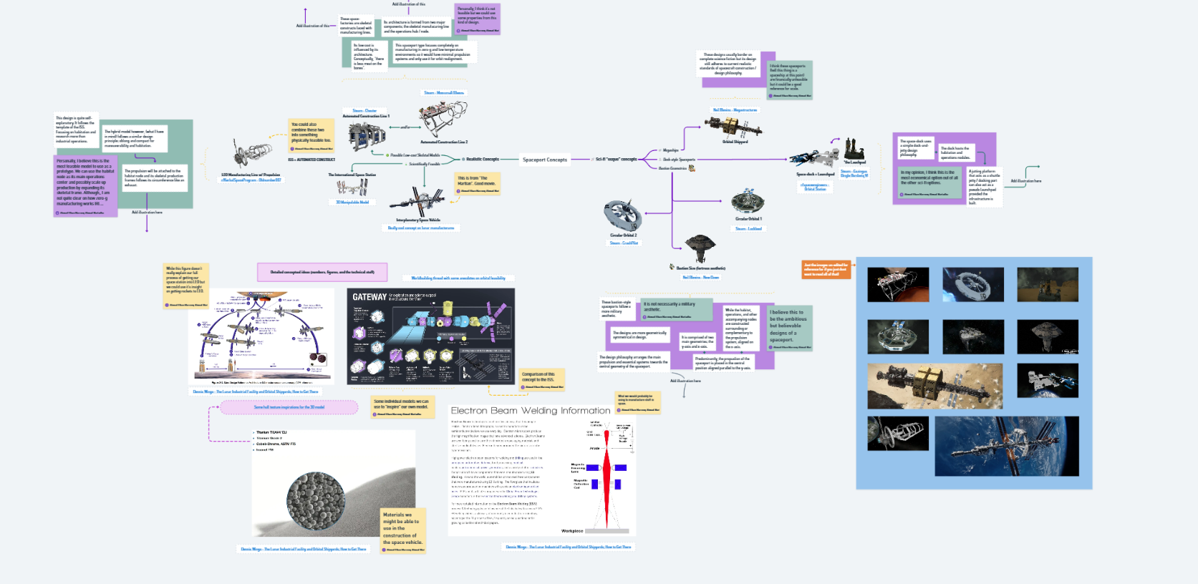

https://whimsical.com/concept-art-visualization-Q9Wuymj2t3G8houEmNaMJ2

## Models

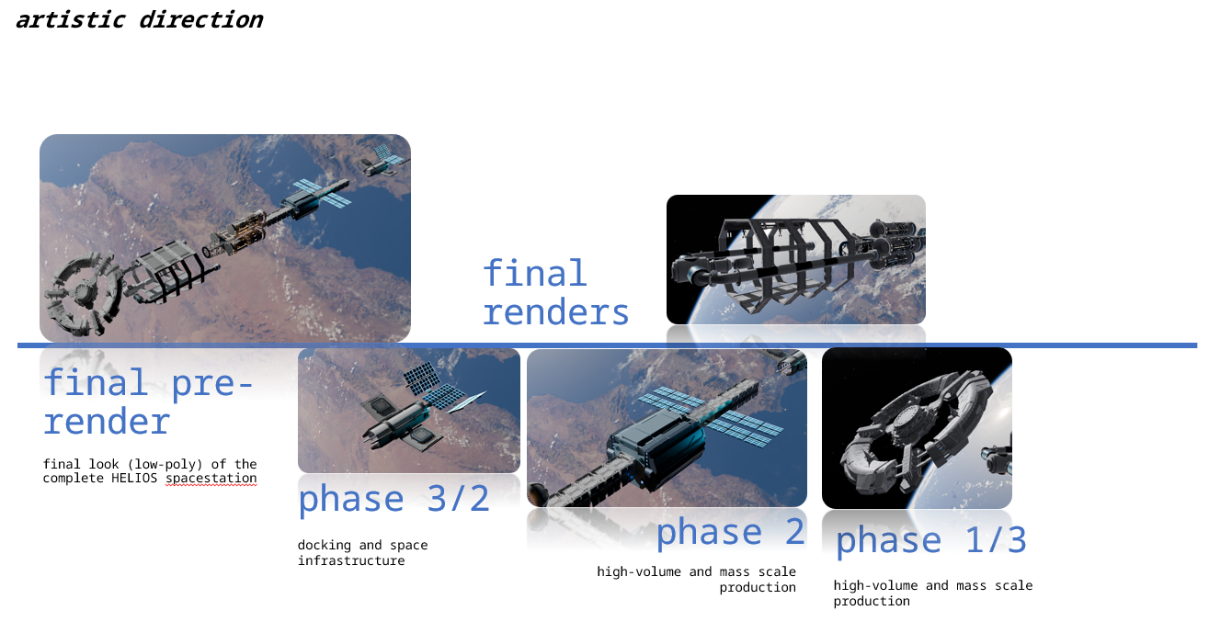

# Conclusion

Further references, cited or uncited will be included in the reference page. Parts of this document also includes reasonings and hypotheses from AI models such as Gemini, Claude, ChatGPT and Microsoft CoPilot.

# References

Cowing, K. (5 Aug, 2025). *NASA Commercial LEO Space Stations Acquisition Strategy*. Retrieved from NASA WATCH: https://nasawatch.com/commercialization/nasa-commercial-leo-space-stations-acquisition-strategy/

ESA. (n.d.). ESA.

Hirschberg, C., Kulish, I., Rozenkopf, I., & Sodoge, T. (13 Jun, 2022). *The potential of microgravity: How companies across sectors can venture into space*. Retrieved from McKinsey & Company: https://www.mckinsey.com/industries/aerospace-and-defense/our-insights/the-potential-of-microgravity-how-companies-across-sectors-can-venture-into-space

Insight. (3 Apr, 2025). *Next in space 2025*. Retrieved from PWC: https://www.pwc.com/us/en/industries/industrial-products/library/space-industry-trends.html

Mordor Intelligence. (n.d.). *Global LEO Satellite Market*. Retrieved from Mordor Intelligence: https://www.mordorintelligence.com/industry-reports/low-earth-orbit-satellite-market

OrbitFab. (30 Aug, 2022). *OrbitFab Announces Hydrazine Refueling Service on Orbit*. Retrieved from OrbitFab: https://www.orbitfab.com/news/hydrazine-fuel-price/

Petrova, M. (20 Aug, 2023). *Why startups are investing millions to make drugs and semiconductors in space*. Retrieved from CNBC: https://www.cnbc.com/2023/08/20/startups-investing-millions-to-make-drugs-and-semiconductors-in-space-.html